Orator’s Report
on the 6th Degree
Intimate Secretary
May 17, 2021
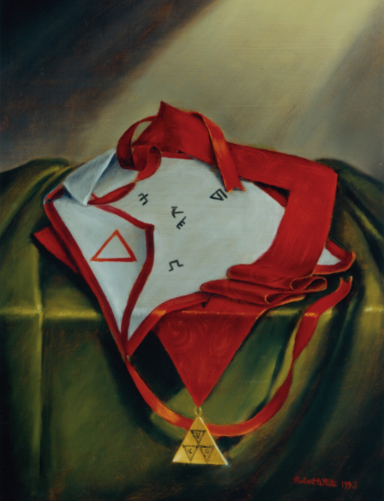

The apron of the 6th Degree is made of white lambskin, edged with bright crimson

Bremerton Valley of the Scottish Rite

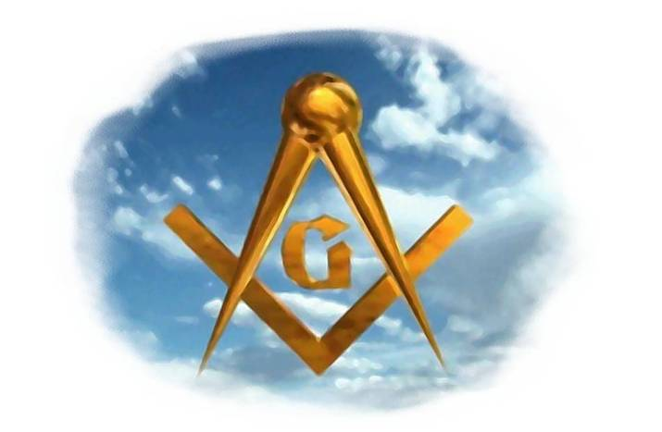
The Legend: This degree continues the Hiramic legend after the death of Master Hiram. Hiram the King of Tyre has endowed Solomon with cedars, firs, and gold according to his desire, and then King Solomon gave King Hiram 20 cities in the land of Galilee. King Hiram, King of Tyre, has come in anger to complain about the dilapidated condition of the cities which Solomon gave him in return for his assistance in the building of the temple, they did not please him (1 Kings 9: 11-12). Although the biblical account ends like this, the story lengthened to provide certain lessons. The plot of the story refers to this agreement between King Solomon and King Hiram of Tyre.
The Setting: This degree takes place in King Solomon’s audience chamber. Hangings and a covering of the Altar are in black with silver tears. In this Degree they serve to remind us of the great affliction suffered by our former Brothers over the death of Hiram and to emphasize in our minds the virtues of Hiram.
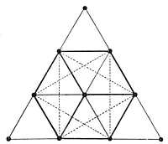
The three candelabra with nine lights each are arranged forming three sets of three equilateral triangles, the Triple Delta. In the works of the Symbolic Degrees of the Scottish Rite, the Pythagorean Tetractis is an important symbol. It is a simple 10 point diagram arranged as shown:
Within its perimeter are many important symbols that are revealed on stage through the ceremonies and lessons of many degrees. The Triple Triangle is the first example in the American system of the Scottish Rite and can be seen, connecting the appropriate dots in the illustration.
The Ritual: The candidate represents Zabud, a faithful servant of King Solomon. The other main characters are King Solomon and King Hiram. The drama begins when the candidate sees King Hiram rushing into King Solomon's adience Chamber. The candidate is then placed outside the Chamber near a half-open door and instructed to listen carefully. He sees King Hiram bitterly accusing King Solomon of dishonesty. King Hiram affirms that he is not honest who does not keep his word both in the spirit and in the letter.
When Solomon begins to explain his intentions, King Hiram surprises Zabud and accuses Solomon of placing spies at the door. He rushes to the door catching Zabud. Solomon wisely advises King Hiram to calm down and reflect on why Zabud should be tried and heard in his own defense. When it is discovered that his motives were pure, he is rewarded rather than punished. And is invested with the collar, apron, and jewel of the degree.
Per KJV 2 Chronicles 8: 2, Solomon rebuilt the cities that King Hiram had given back to Solomon, and caused the children of Israel dwell there. The two Kings strengthen their Brotherhood and agree to carry out a new Treaty between their countries.
The Lecture The degree seeks to incite us to act in such a way that our memory is honored among Masons.
Zeal in the service of another is the noble expression of selflessness. Generosity as a Masonic virtue is more than charity. It is a commitment also of time and talent, sacrifice and dedication. Do not give measure for measure, but rather return abundantly to repay the smallest favor.
The man who is owed gratitude keeps the scales in his favor. As men we were created to care for and nourish one another and thus we are counseled to be zealous in the practice of that truly Masonic tenant: Brotherly Love.
Zeal without discretion is fanaticism. The fanatic is ruled by his passions rather than by his reason; He is led by emotions rather than judgment.
The wise Mason is a peaceful man, avoiding violence and argument. When our brethren are in disagreement, we should not take sides and incite more argument. Let us instead seek that common ground which unites men of reason and respects honest differences of opinion.
The moral teaching of this degree emphasizes the importance of zeal tempered by discretion. We also receive the counsel of King Hiram given to Solomon. "Obey not only the letter, but the spirit of the law." We hear also of the priceless gift of friendship whose worth exceeds all earthly things.
DUTIES: Be enthusiastic, faithful, disinterested, benevolent, act as a peacemaker.
LESSONS: Zeal and fidelity to duty are always rewarded.
FOR REFLECTION: Why be a peacemaker?
IMPORTANT SYMBOLS: The triple Delta, King Solomon, King Hiram and the crimson color.
The Apron is made of white lambskin, edged with bright crimson; an equilateral triangle is embroidered on the flap. The designs on the Apron are Phoenician letters; in the center are the two letters on the Fifth Degree Apron. Three additional letters: two in the upper corners and one near the bottom. These are the initials of the words that signify a covenant, agreement or Divine Law, an offer to attain salvation from a vow.
The jewel is a triple Delta superimposed on an equilateral triangle of gold. Each Delta has a central design made up of one of the astrological signs for the Sun, Moon, and Mercury. The jewel's shape is based on the Masonic interpretation of the Pythagorean Tetractys.
The cordon is a wide band in light crimson, used from right to left, or a collar of similar material, with the jewel suspended from it.

Adapted from the Spanish version of Rex R. Hutchen’s book A Bridge to Light

